Spatial interpolation for mapping the environment

Gerard B.M. Heuvelink
Soil Geography and Landscape group
Wageningen University, the Netherlands

Abstract
A common problem in the Earth and environmental sciences concerns the spatial interpolation of variables from point measurements. Examples of such variables are precipitation, temperature, air quality, soil and water pollution, and aboveground biomass. The history of spatial interpolation goes back to the early days of geoinformatics, when basic algorithms such as nearest neighbour interpolation and inverse distance weighted interpolation were developed. Geostatistics took it a step further by developing kriging interpolation, which weighs the measurements in accordance with their degree of spatial correlation and has the additional advantage that it quantifies the interpolation error. Over the years many different kriging algorithms have been developed. Currently regression kriging is very popular. It typically produces more accurate maps than ordinary kriging because in addition to information derived from nearby point measurements, it also benefits from information contained in explanatory environmental variables, as for example derived from remote sensing. Extensions of regression kriging to space-time interpolation have also been made. Machine learning methods, such as random forest, gradient boosting and artificial neural networks, have recently become a serious competitor of kriging. These methods rely solely on the relation between the dependent and explanatory variables and are very flexible in their model structure. This can improve the map accuracy substantially, if at least sufficient training data are available. A very recent improvement of machine learning for spatial interpolation is given by a technique known as Random Forest Spatial Interpolation. This technique closes the spatial interpolation circle, by revisiting the original ideas and incorporating measurements from neighbouring locations in the set of explanatory variables of a random forest model. In this paper I review the historic development of spatial interpolation techniques and highlight the contributions to this field by researchers of the Geodesy and Geoinformatics group of the Faculty of Civil Engineering, University of Belgrade.

1 Introduction
Many variables in the Earth and environmental sciences can only be measured at a finite number of point locations, while researchers and end users may need values of these variables for all locations in an area of interest. Examples of such variables are groundwater level, soil organic matter content and the grade of valuable minerals such as copper, nickel and gold in ore deposits. Other variables can more easily be measured exhaustively in space through remote sensing, but these indirect measurements are often only proxies of the true variables and ground-truth observations are still needed for mapping. Examples of such variables are precipitation, temperature, aboveground biomass and air quality. In all of these cases there is a need for spatial interpolation.

Spatial interpolation has a long history that goes back to the early days of geo-information science. Methods for spatial interpolation have evolved substantially during the past decades and have become much more refined and elaborate, among others through the use of remote sensing information as ‘covariates’ in addition to point observations. All developments aim to use the available information optimally to obtain a map of the variable of interest that is as close as possible to the truth. Thus, the quest for ‘optimal spatial interpolation’ has been a topic of research by geographers and environmental scientists for many decades and continues as new methods are developed and new data come available. In particular, research is also directed to quantification of the spatial interpolation error.

The purpose of this chapter is to give a brief historic account of spatial interpolation methods and provide an outlook of future developments. Deterministic interpolation methods are the oldest and presented first. Next, geostatistical interpolation is discussed and finally, machine learning for spatial interpolation is addressed. Contributions to these more recent developments by researchers of the Geodesy and Geoinformatics group of the Faculty of Civil Engineering, University of Belgrade will be emphasised.

This chapter does not aim to provide a comprehensive and detailed account of spatial interpolation methods. There are many text books that provide detailed explanations and illustrations of the various methods discussed, such as Li and Heap (2008) and Burrough et al. (2015).

2 Deterministic spatial interpolation methods
It is useful to start with a mathematical formulation of the basic spatial interpolation problem. Let $z=\{z(x), x∈D\}$ be the variable of interest defined in a geographic domain $D$, where $x$ refers to geographic location and is taken here as a two-dimensional coordinate. We will further assume that a suitable geographic projection is used, such that distances between points are properly defined and satisfy basic conditions of a normed, metric space.

Let $z$ be measured at a finite number of locations $x_{i}, i=1,…,n$, and let the goal be to predict $z(x_{0})$, where $x_{0}$ is an arbitrary location in $D$, from the observations $z(x_{i})$:

$\hat{z}\left(x_{0}\right)=f\left(z\left(x_{1}\right),…, z\left(x_{n}\right)\right)$ (1)

Different methods can now be used to come up with a function $f$.

Nearest neighbour spatial interpolation
Perhaps the simplest spatial interpolation method is to let the prediction at location $x_{0}$ be equal to the nearest observation. This may be written as a weighted linear interpolation model:

$\hat{z}\left(x_{0}\right)=\sum_{i=1}^{n}{λ_{i}∙z(x_{i})}$ (2)

with all weights $λ_{i}$ set to zero except for the nearest observation, which has a weight equal to one. Figure 1 gives a graphical illustration for a simple case of $n=8$ observations. The interpolation results in a map with so-called ‘Thiessen polygons’ or ‘Voronoi diagrams’. The interpolated value is constant within a polygon and makes discrete jumps when crossing the border between two polygons (i.e., when the nearest observation changes). This discontinuity may not be very realistic for real-world phenomena but nearest neighbour maps do support a visual exploratory analysis of spatial data and can also be used for variables measured on a categorical scale, such as soil type or land use.

Inverse distance weighting
A slightly more advanced approach is to use Eq. 2 and let all weights have a positive value that is directly derived from the distance between the observation and prediction points:

$λ_{i}=\frac{c}{{d_{i}}^{p}}$ (3)

where $d_{i}=\left\|x_{0}-x_{i}\right\|$ is the distance between $x_{0}$ and $x_{i}$, $p$ is a power (often taken as 2, i.e. inverse squared distance weighting) and $c$ a normalizing constant to ensure that the weights add up to one. Figure 1 shows an example. While being very simple and straightforward, inverse distance interpolation is still often used in geo-information science and can in fact have remarkable good performance in specific cases (Sekulić et al. 2020a).

Splines
Splines are piecewise polynomials whose parameters are chosen such that a smooth surface is obtained that passes through the measurements. In the case of cubic splines, third-order polynomials are used and their parameters are chosen such that the resulting surface is continuous and twice differentiable, guaranteeing smooth surfaces that have neither discontinuities nor abrupt changes in the surface slope. Splines are often used in one-dimensional applications but also work in two-dimensional space and are therefore routinely used in spatial interpolation. There are many different variants of splines, one of which is thin plate spline, which aims for a trade-off between the smoothness (integral of the squared second derivative over the geographic domain) and the goodness (closeness of the interpolated surface to the measurements). Figure 1 shows an example. Note that sacrificing goodness for smoothness implies that the method no longer yields an exact interpolator (i.e., interpolations at measurement locations may differ from the measurements themselves).

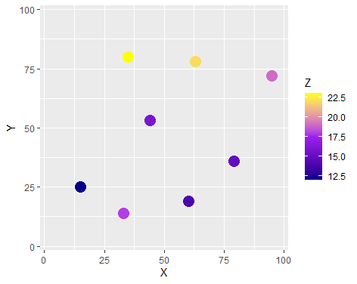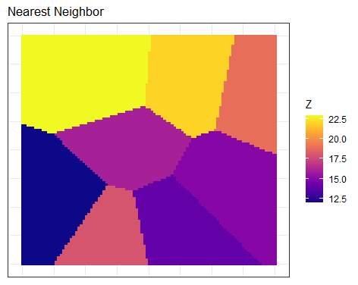
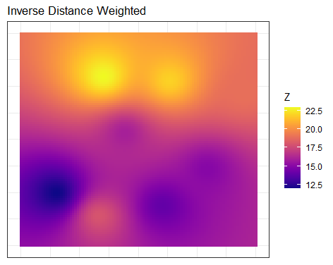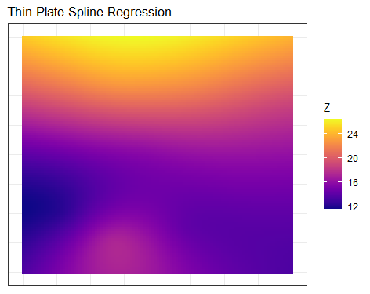

Figure 1 Simplified synthetic example of deterministic spatial interpolation. Top left panel shows the measurements, the other panels show interpolations with three different methods.

Other methods
Other commonly used deterministic spatial interpolation methods are radial basis functions, which have similarity to splines; triangular irregular networks, which divide the study area in triangles that are modelled as linear planes (e.g. Delaunay triangulation); and trend surfaces, which fit a single polynomial to the entire geographic domain.

Note that all deterministic interpolation methods are inspired by the first law of geography, which states that “everything is related to everything else, but near things are more related than distant things” (Tobler 1970). This explains why in all these methods neighbouring observations get larger weights than more distant observations. But otherwise the choice of weights is still fairly arbitrary, and not derived from theory or optimized in any way (except if one uses cross-validation to calibrate the interpolation model, see Section 5).

3 Geostatistical interpolation methods
Geostatistics has its roots in mining (e.g. Journel and Huijbregts 1978), but has become increasingly popular in other scientific domains since the 1980s and is nowadays routinely used in various fields, such as soil science, climatology, hydrology and geography. Geostatistical interpolation is known as kriging, named after the South-African mining engineer Danie Krige (1919-2013). A fundamental difference between deterministic spatial interpolation methods and kriging is that the latter is model-based, meaning that the spatial interpolation is derived from a statistical model of spatial variation. Given this model, the spatial interpolation is no longer arbitrary but ‘optimal’, meaning that it has the smallest expected squared prediction error among all possible interpolations.

The basic geostatistical model assumes that the variable of interest $z$ is a realisation of a random field $Z$, which typically satisfies:

$Z\left(x\right)=m\left(x\right)+ε(x)$ (4)

where $m$ is a spatial ‘trend’ and $ε$ a stochastic residual. Note the distinction between lower case $z(x)$ (a realisation, a deterministic number) and upper case $Z(x)$ (a random variable, characterised by a probability distribution). In the case of ordinary kriging, $m$ is assumed to be constant. The stochastic residual is then taken as a normally distributed variable that has zero mean and constant variance, and whose spatial correlation is characterized by a semivariogram:

$γ\left(h\right)=\frac{1}{2}E[{\left(Z\left(x\right)-Z\left(x+h\right)\right)}^{2}]$ (5)

where $h$ is the separation distance between two locations and $E$ refers to mathematical expectation.

Note that Eq. 5 assumes that the semivariogram $γ$ only depends on the distance between locations and not on the locations themselves. This so-called second-order stationarity assumption is invoked in order to be able to estimate the semivariogram from measurements. But even then semivariogram estimation requires at least 100 measurements (Webster and Oliver 2007, Section 6.1.2), implying that geostatistical interpolation cannot be used in cases where only a few dozens of measurements are available. Note also that the separation distance $h$ in Eq. 5 is a vector that has two (or three) geographical coordinates. Modelling is often simplified by assuming isotropy, in which only the Euclidean distance matters, i.e. by assuming $γ\left(h\right)=γ(\left\|h\right\|)$.

If sufficient measurements are available then the semivariogram can be estimated from them using the methods of moments or maximum likelihood estimation (Webster and Oliver 2007). This is a key step in any geostatistical analysis, because the semivariogram is needed in kriging.

Ordinary kriging
Ordinary kriging predicts $Z(x_{0})$ using Eq. 2, but unlike inverse distance interpolation the weights $λ_{i}$ are not derived from the distances between observation and prediction points, but from their degree of spatial correlation, as characterized by the semivariogram. This is well-explained in text books (e.g. Webster and Oliver 2007, Chilès and Delfiner 2012). Similar to inverse distance weighted interpolation, closer measurements typically have larger weights than distant measurements (because they have a higher correlation), but the spatial configuration of the measurements also matters. Clustered measurements tend to get lower weights than isolated measurements, which intuitively makes sense because clustered data have redundant information.

Ordinary kriging typically produces a smooth interpolated surface that reproduces the large scale pattern in the measurements. This is particularly the case when the semivariogram exhibits a substantial amount of short-distance spatial variation (i.e., a nugget variance). Thus, ordinary kriging usually does not show ‘pockets’ or ‘islands’ of high or low predictions around a measurement location as obtained in inverse distance interpolation. Figure 2 shows an example of ordinary kriging of the long-term annual precipitation in Turkey from measurements at 205 meteorological stations.

An important advantage of geostatistical interpolation over deterministic spatial interpolation methods is that it quantifies the interpolation error, by means of the kriging variance. Assuming that the kriging error is normally distributed, this allows to compute the lower and upper limits of a prediction interval, such as shown for ordinary kriging in Figure 3. Note that the kriging standard deviation, also shown in Figure 3, tends to be relatively small close to sampling locations and large further away from them. Figure 3 also indicates that the ordinary kriging map of annual precipitation shown in Figure 2 is very uncertain, which is no surprise given that only 205 measurements were used to predict annual precipitation for an entire country.

Ordinary kriging was popular in the 1980s and 1990s, but nowadays its use has become almost obsolete. This is because it only relies on the measurements $z(x_{i})$, as did the deterministic interpolation methods presented in Section 1. But with the advent of remote sensing there is often much more information available that can be used to improve spatial interpolation. For example, we know that soil pH depends on soil forming factors such as parent material, climate, terrain morphometry and land use (Jenny 1994), and since information or ‘proxies’ about these factors are exhaustively available as maps, they should be used to improve the interpolation. This can be done in geostatistics using a technique known as regression kriging.

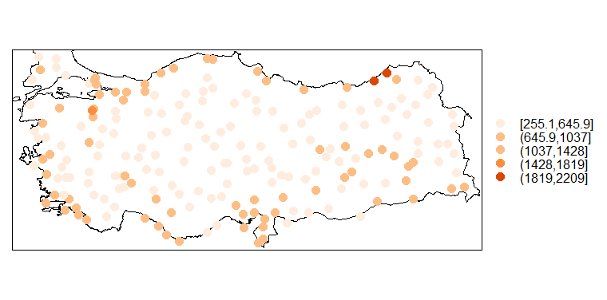
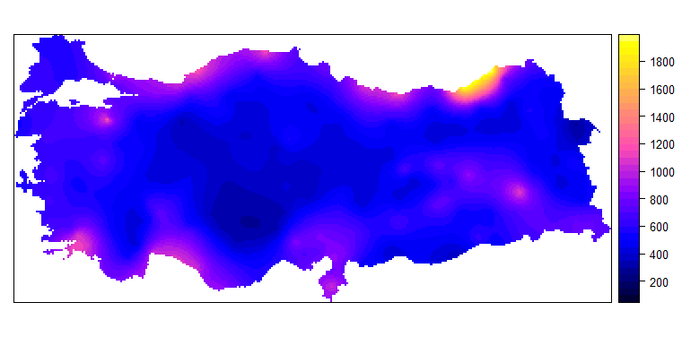
Figure 2 Ordinary kriging of long-term annual precipitation in Turkey. Precipitation measurements (mm) at 205 stations (top) and ordinary kriging map (bottom).

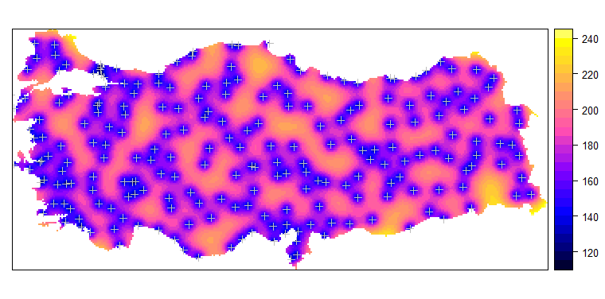
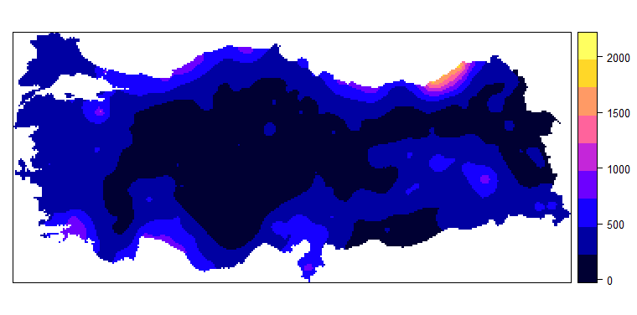
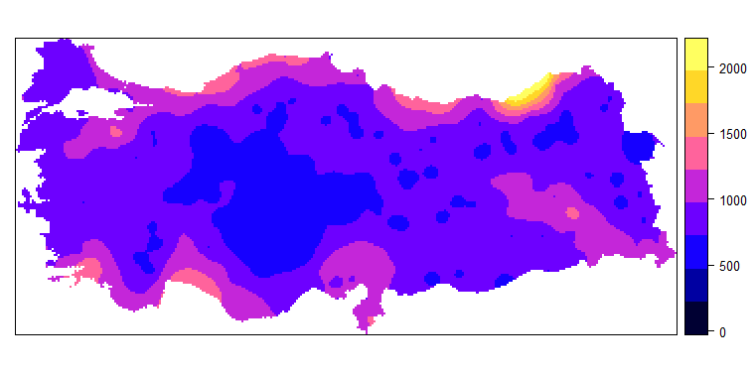
Figure 3 Interpolation uncertainty derived from ordinary kriging of long-term annual precipitation in Turkey. Ordinary kriging standard deviation (top), and lower (middle) and upper (bottom) limits of a 90% prediction interval. White crosses in standard deviation map are measurement locations.

Regression kriging
Regression kriging is also known as kriging with external drift and universal kriging, with subtle differences that are not important here. The crucial difference between regression kriging and ordinary kriging is that in regression kriging we no longer assume that the trend in Eq. 4 is constant. Instead we assume that it is a function of explanatory variables, also known as ‘covariates’. Using the example of annual precipitation in Turkey, it makes sense to include elevation and distance to the coast as covariates. The top panel in Figure 2 shows that annual precipitation tends to be higher closer to the coast, and from climatology we also know that there is a correlation between annual precipitation and elevation. Thus, we might arrive at the following model:

$Z\left(x\right)=β_{0}+β_{1}∙f_{1}\left(x\right)+β_{2}∙f_{2}\left(x\right)+ε(x)$ (6)

where the $β_{i}$ are regression coefficients and the $f_{i}$ are covariates (i.e., elevation and distance to coast). The stochastic residual in Eq. 6 may be spatially correlated and is modelled by a semivariogram as in ordinary kriging, but it will typically have a smaller variance because part of the spatial variation in the dependent variable is explained by the covariates. Figure 4 shows the regression kriging prediction of the annual precipitation in Turkey. Note that the ordinary kriging and regression kriging maps are fairly similar because in this specific case the covariates do not explain much of the spatial variation in annual precipitation. However, Figure 4 clearly shows that the regression kriging map is less smooth and has fine-scale spatial detail. These are the result of the influence of the elevation map.

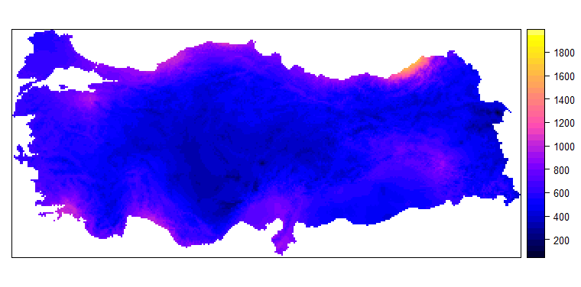
Figure 4 Regression kriging prediction of long-term annual precipitation in Turkey, using elevation and distance to coast as covariates.

Regression kriging has become the geostatistical interpolation ‘workhorse’ since the start of this century. More elaborate regression kriging models can make use of many covariates, such as outputs of remote sensing instruments and mechanistic models. In such case, careful attention should be paid to model selection, that is the procedures used to decide which covariates are included in the trend and which are not, and how.

The Geoinformatics group of the University of Belgrade has contributed much to the development and application of regression kriging. Among others, they addressed regression kriging in space-time and applied this to global estimation of daily temperatures (Kilibarda et al. 2014). Figure 5 shows an example.
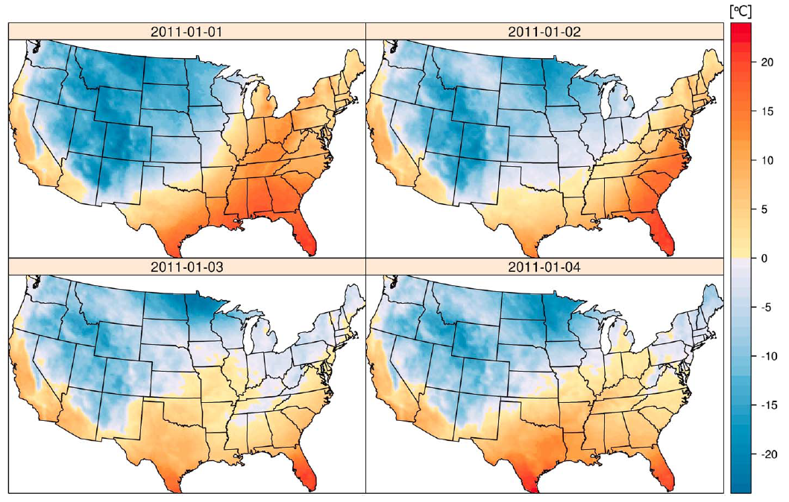
Figure 5 Regression kriging maps of mean daily temperature for the first four days in January 2011, covering coterminous USA in Albers equal-area projection (from Kilibarda et al., 2014).

- Machine learning for spatial interpolation
While geostatistical interpolation can incorporate covariates to help explain spatial variation, much emphasis is still on modelling the (residual) spatial variation through a semivariogram. However, with the rapid development of remote sensing and other instruments (such as UAVs), the number of covariates and their predictive power has grown that much over the past decades that focus has shifted from modelling the stochastic residual to improved modelling of the trend. This development received a boost with the maturing of machine learning models (Hastie et al. 2009, James et al. 2013), which proved to be very flexible in extracting relevant information from the covariates. It is beyond the scope of this chapter to provide a comprehensive review of machine learning algorithms for spatial interpolation. Instead we describe the main principles, name a few techniques that are often used, and illustrate their use with a few examples.

Machine learning, also termed statistical learning, refers to a set of tools for modelling relationships in large and complex data sets. It models the relation between a dependent and explanatory variables in a very flexible way, much beyond simple linear models such as the trend in Eq. 6, and uses the data to ‘learn’ the relationship. It often makes use of tree-based structures but not always, and can be used both for classification and regression. It does not explicitly take the spatial context into account, but merely predicts the dependent from the covariates, be it spatial variables such as temperature, soil organic matter and ozone concentration, or non-spatial variables such as stock market index, cancer type or fraud risk.

Common machine learning methods used for spatial interpolation are random forest, support vector machines, artificial neural networks and gradient boosting (James et al. 2013). These methods have also been used for mapping by the Geoinformatics group of Belgrade University (e.g. Kovačević et al. 2010, Bajat et al. 2011a, Marjanović et al. 2011, Samardzić-Petrović et al. 2016). Since machine learning methods are very flexible, there is a risk of overfitting and hence a data set is typically split in three: training, validation and test data. The training data are used to calibrate the model, the validation data are used to optimise meta-parameters and prevent overfitting, and the test data are used to evaluate the prediction performance (see also Section 5 below). The splitting of the data set into three subsets is often done repeatedly, in a nested k-fold cross-validation mode (e.g. Pejović et al. 2018).

Figure 6 shows an example from Čeh et al. (2018) where the random forest algorithm was used to interpolate prices and sales ratios of apartments in the city of Ljubljana. Random forest and gradient boosting have also been used to map soil properties at continental and global scales (e.g. Hengl et al. 2017, Hengl et al. 2021, Poggio et al. 2021). Figure 7 shows an example. The use of machine learning for environmental modelling and mapping is also a key research theme of the Geoinformatics group of Belgrade University, among others demonstrated by the GeoMLA conference held in Belgrade in 2016 (Tadić and Kilibarda 2018).

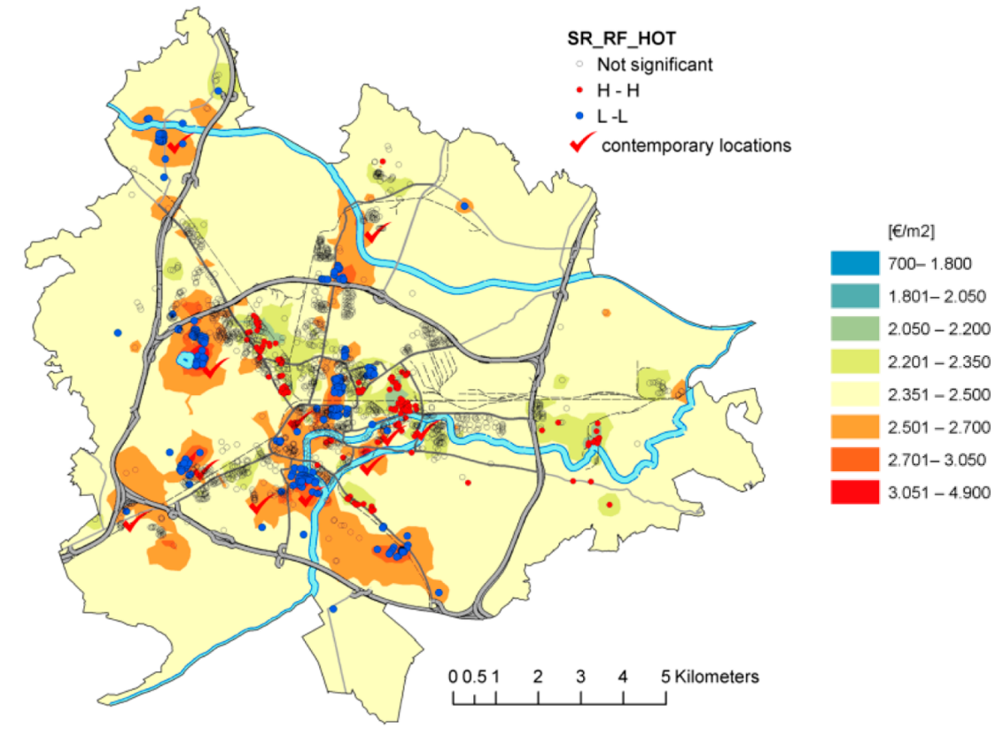

Figure 6 Map of sales ratio of apartments in the city of Ljubljana as obtained using random forest spatial interpolation (from Čeh et al. 2018).

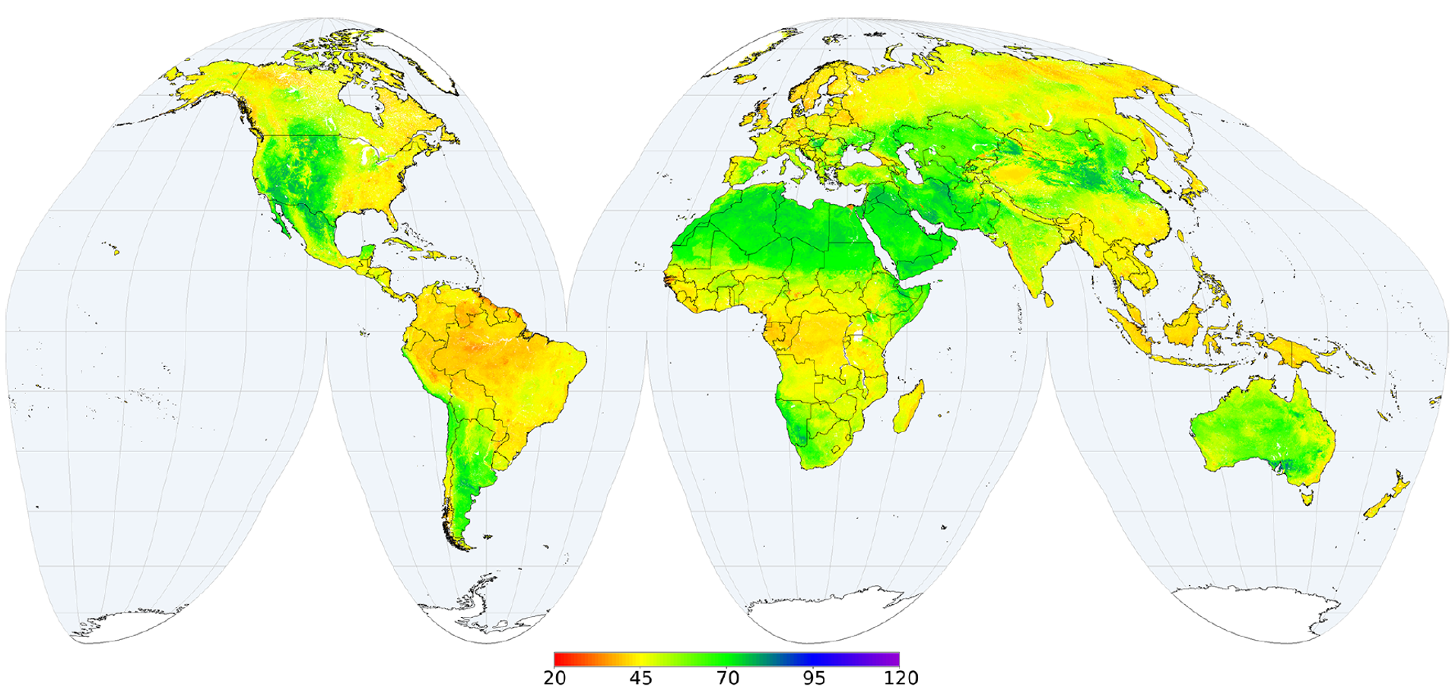

Figure 7 Random forest interpolated map of global soil pH (10 pH) for the 60 to 100 cm depth interval (from Poggio et al. 2021).

It was mentioned before that an important advantage of geostatistical interpolation over deterministic interpolation is that it quantifies the interpolation error. Machine learning seems less-developed in this respect, although there are some machine learning algorithms that produce spatially explicit measures of the prediction accuracy. One such method is Quantile Regression Forests (Meinshausen 2006), which derives the quantiles of the predictive probability distribution, so that prediction error standard deviations and prediction intervals can be computed. Figure 8 gives an example. Note that machine learning and kriging can also be combined by first using machine learning to model the trend, and next modelling the residual with ordinary or simple kriging. The kriging step then quantifies the interpolation error, although one should be aware that this approach ignores uncertainty about the trend.

In spite of the recent development, good performance and many successes obtained with machine learning for spatial mapping, in essence it is not a spatial model and does not take the geographic locations and spatial context into account when calibrating a model and making predictions. This suggests that there should be ways to further improve these methods. Several approaches have been proposed and tested, but arguably the most innovative idea to let machine learning better exploit spatial context and neighbourhood information was presented in Sekulić et al. (2020a, 2021). The idea is simply to include the nearest observations and their distances from the prediction location as covariates of the machine learning model (Figure 9). It is interesting to observe that the nearest observations are often picked up by the machine learning algorithm as important covariates and thus improve map accuracy. In a way this brings us back to the deterministic interpolation methods discussed in Section 1, but then in a much more flexible way that can also benefit from external, environmental covariates.

A different approach to incorporate spatial context in machine learning mapping has recently emerged, known as deep learning or convolutional neural networks (Goodfellow et al. 2016). The key element of this approach is that spatial predictions are not only derived from the values of the covariates at the prediction location, but also from covariate values in a local neighbourhood. The method is promising and multiple applications in the environmental sciences have been done (e.g. Ng et al. 2019, Anantrasirichai et al. 2021, Yu and Liu 2021), but it is computationally intensive and requires a very large training set.

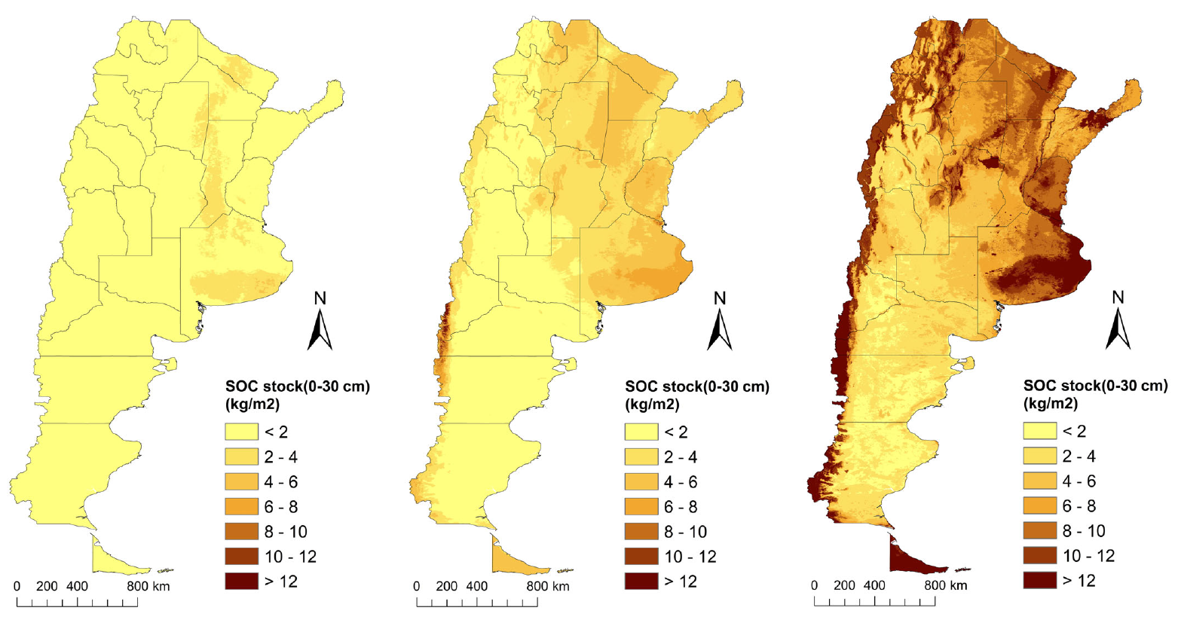
Figure 8 Maps of the 5 (left), 50 (centre) and 95 (right) percentiles of soil organic carbon (SOC) stock for Argentina for the year 2017 as obtained with Quantile Regression Forest (from Heuvelink et al., 2021).

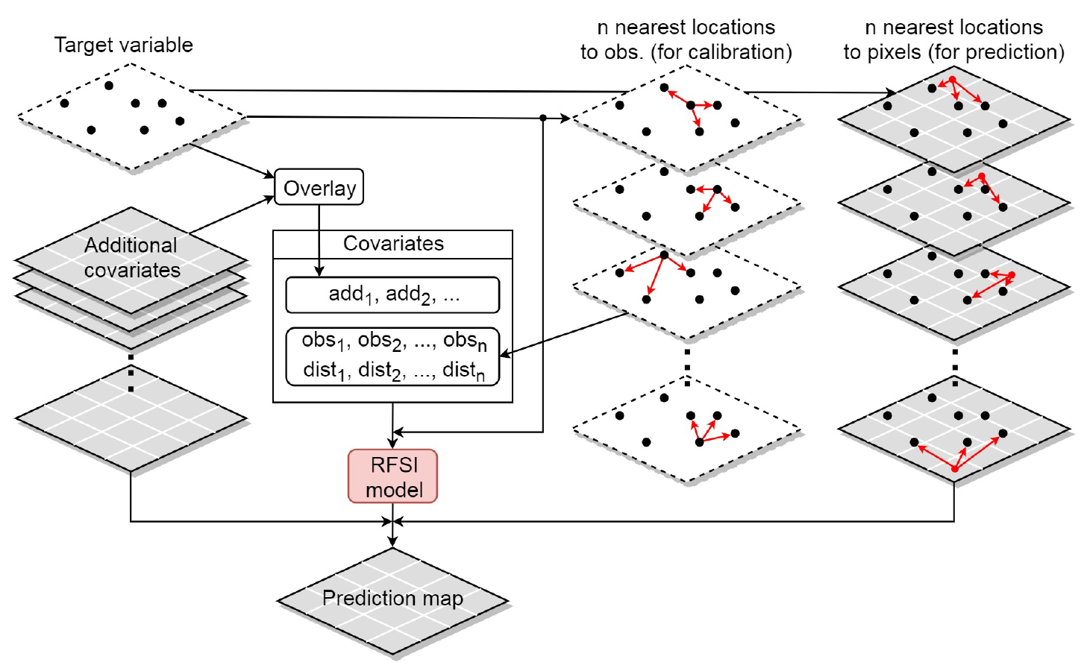
Figure 9 Schematic overview of the Random Forest Spatial Interpolation algorithm (from Sekulić et al., 2020a).

5 Choosing between interpolation methods and statistical validation of interpolated maps
Many spatial interpolation algorithms have so far been reviewed in this chapter, which naturally leads to the question which algorithm should be used in any given situation. Clearly the choice between methods depends on many factors, some of which are quite pragmatic. For instance, users who are not familiar with geo-information science, geo-computation and software implementations of machine learning may be reluctant to go for complex machine learning algorithms. Similarly, geostatistical interpolation requires experience with geostatistical theory and methods. If such experience is lacking, it may be best to go for simpler interpolation methods, such as nearest neighbour interpolation.

Another important consideration is data availability. Clearly one cannot use methods that heavily rely on covariate information if such information is not available or useful. This may for instance happen if one maps soil pollution in an urban area (Qiao et al. 2018), although for sufficiently large areas one may usually benefit from climate information, topography and distance to the pollution source (Pejović et al. 2017). Kriging requires sufficient measurements of the dependent variable to be able to estimate the semivariogram reliably, while machine learning methods typically perform well only when a very large data set is available for model calibration. These methods are products of ‘big data science’, and may work well in data rich cases (for example, we can easily collect thousands of pictures of cats and dogs to let a machine learning model learn to distinguish between cats and dogs), but if every single observation is expensive (such as in ore exploration and groundwater monitoring) then machine learning may not be the best choice.

Computation time may also be a limiting factor. Geostatistical and machine learning methods can be very time consuming (e.g. Sekulić et al. 2020a) and require state-of-the art hardware and professional infrastructure. Much of this can nowadays be addressed by using high performance computing facilities from external sources such as Amazon and Google, but use of these facilities is costly and requires skilled personnel.

Perhaps the most important consideration when choosing between spatial interpolation methods is their prediction accuracy. As noted before some methods provide an internal measure of the interpolation error (i.e., the kriging standard deviation and quantiles as obtained with Quantile Regression Forests), but these are built on assumptions that make them less reliable. Thus, there is also a need for an external accuracy assessment using independent observations obtained with probability sampling.

Probability sampling and design-based statistical inference for map accuracy evaluation
Accuracy assessment of an interpolated map can best be done using an independent data set obtained with probability sampling (Stehman 1999, Stehman and Foody 2009, Wadoux et al. 2021). Taking the simplest case of simple random sampling, unbiased estimates of common map accuracy metrics such as the Mean Error, Mean Absolute Error, Root Mean Squared Error, Map Purity, Model Efficiency Coefficient and the Prediction Interval Coverage Probability can easily be derived from the sample. If these metrics are computed for multiple spatial interpolation methods, then the one that has the best performance may be preferred. Moreover, if probability sampling is used then confidence intervals can also be obtained for all metrics, which allows to test whether the best performing interpolation method has a statistically significant better performance than other interpolation methods.

Map accuracy assessment with convenience sampling and cross-validation
While map accuracy assessment with independent data obtained with probability sampling is preferred, in many practical cases one does not have the luxury to collect validation data in this way. One is therefore forced to use the existing data for the accuracy assessment, either by data splitting or cross-validation. In data splitting the total data set is (randomly) divided into a subset used for model calibration and prediction and a subset for evaluation of the model performance. Cross-validation does essentially the same, but then repeatedly so that all observations are used both for model calibration and prediction as well as for evaluation of the map accuracy. For instance, in $k$-fold cross-validation the total data set is randomly divided in $k$ equally sized subsets, after which each fold is put aside and used for accuracy evaluation one by one, each time using the other $k1$ folds for model calibration and prediction. Figure 10 gives an example of accuracy assessment using leave-one-out cross-validation, where the number of folds $k$ equals the number of observations.

Cross-validation is often used in practice to evaluate the accuracy of interpolated maps, but one should be aware that there is no guarantee that the so-obtained estimates of the map accuracy metrics are unbiased. In particular, default cross-validation may be criticized if the data are highly spatially clustered, because in such case the estimates will be dominated by the performance in data-rich subareas, where the interpolation error is usually smaller. To avoid over-optimistic estimates of the accuracy metrics a method known as spatial cross-validation has been proposed (e.g. Brenning 2005, Roberts et al. 2017), but these methods start from the wrong premise that spatial autocorrelation must be avoided and tend to produce over-pessimistic results (Wadoux et al. 2021). The spatial mapping research community is still in need for cross-validation methods that provide realistic and reliable estimates of map accuracy metrics.

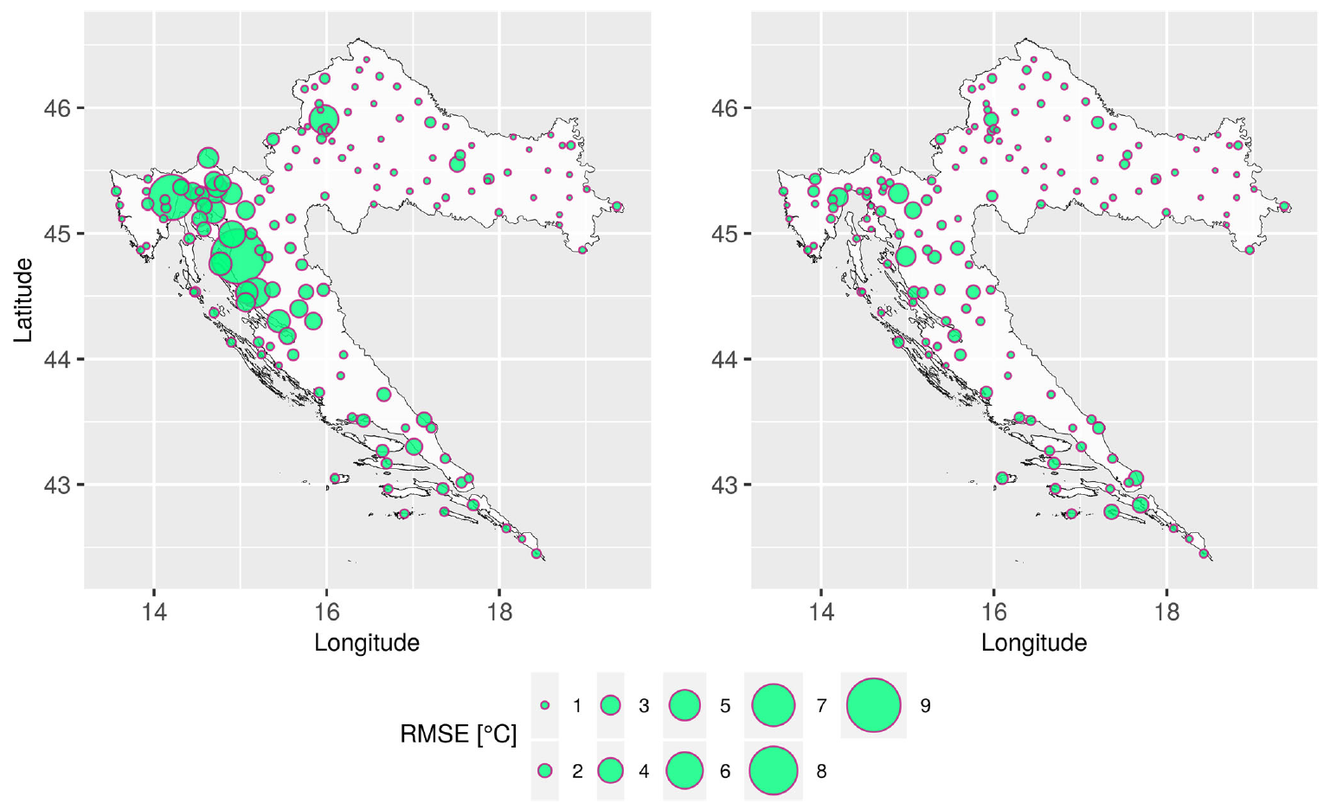
Figure 10 Annual average Root Mean Squared Error (RMSE) of mean daily temperature predictions for Croatia as obtained using spatio-temporal regression kriging and leave-one-out cross-validation (from Sekulić et al., 2020b).

6 Conclusions and outlook
Spatial interpolation for mapping the environment has come a long way, starting out with simple deterministic methods from the early years of geo-information science to the advanced geostatistical and machine learning methods of today. What can we conclude from these developments and what developments can we expect in the near future?

One important conclusion is that the past decades have shown that spatial interpolation can benefit greatly from covariate information. We are much beyond the stage that measurements at sampling points are the only source of information. We now have clever algorithms that extract useful information from covariates and in this way explain a large portion of the spatial variation of the dependent variable. This development will likely continue in the future since covariate information will only grow and become more detailed, while data science will continue to refine and develop statistical learners that optimally extract information from covariates. However, it is important to recognize that these approaches can only deliver if there are sufficient observations of the dependent variable as required by model calibration. More research is needed into how many observations are needed to properly train a machine learning model and how this depends on the specific algorithm and its hyperparameters. There will always be cases in which the number of observations is too small to apply machine learning or geostatistical interpolation, so that deterministic interpolation methods are still useful.

Simple deterministic interpolation methods will also stay because advanced spatial interpolation methods require skilled and experienced staff that may not always be available. Even though spatial interpolation tools will become more user-friendly and may render a geostatistical or machine learning interpolated map with just one mouse-click, there is a serious risk of getting erroneous results if these methods are used by non-experts. Some common risks are overfitting and extrapolation. Many machine learning algorithms have in-built routines that protect against overfitting, but not all. For example, the number of effective parameters of a geographically-weighted regression model can be very large and hence it is important to ensure that this is in balance with the number of training data (Bajat et al. 2011b). Extrapolation can occur both in geographic space and in feature space (Kilibarda et al. 2015). Geographic extrapolation is easily detected but feature space extrapolation is not obvious and is a serious problem that has not yet received sufficient attention. One solution is to exclude subareas where extrapolation in feature space occurs by using the concept of Area of Applicability (Meyer and Pebesma 2020). Even better would be to develop spatial sampling designs that avoid geographic and feature space extrapolation (e.g. Wadoux et al. 2019).

Given the need for skills it is important that future generations of geo-scientists and geo-engineers are trained in these methods and the technical implementations. Fortunately many groups across the world have the infrastructure and know-how to teach courses on the subject. One excellent example of that is the Geodesy and Geoinformatics group of the Faculty of Civil Engineering of the University of Belgrade.

Many of the advanced spatial interpolation methods also require high-performance geo-computing facilities and the technical know-how that goes with that. Technical developments are rapid and it is only a matter of time until we can map the environmental condition of the world at 10 or 1 m resolution. But we may ask ourselves whether our focus should be on increasing spatial resolution or on improving the map accuracy. We should realize that map accuracy may be more important than map resolution and think of ways to improve it, such as by improving spatial sampling designs and covariate preparation and selection.

The abundance of spatial interpolation methods, simple and advanced, also requires a framework to decide which method to use in which situation. Several criteria were presented in Section 5, the most important of which is the accuracy of the interpolated map. It is important to be able to determine the map accuracy from a sample of ground-truth data, and here further developments are needed, because we have seen that standard cross-validation methods may be deficient, particularly in case of clustered data. Not mentioned so far but important too is that the ground-truth data that are used to assess map accuracy may have measurement errors. These measurement errors should be accounted for when the map accuracy is estimated. For example, when the Mean Squared Error is computed by comparing interpolated values with ground-truth validation data, then the discrepancy between them is not only caused by interpolation error, but also by measurement errors in the validation data. In fact, these measurement errors are also present in the calibration data, and ideally should be included in the model fitting (Delhomme 1978, Van der Westhuizen et al. 2021). For instance, measurements with large measurement error should carry less weight during calibration than measurements with small measurement errors, but exactly how much is not obvious in a machine learning context. This is another area where future research may lead to improvements in spatial interpolation methods.

Some spatial interpolation methods quantify the interpolation error. Examples of these mentioned in this chapter are kriging and Quantile Regression Forest. It would be useful to extend these ‘internal’ uncertainty quantifications to other machine learning algorithms. Interestingly, the spatial pattern of the uncertainty maps as obtained with Quantile Regression Forests may be quite different from that obtained using kriging, while validation with independent observations shows that both approaches provide a realistic assessment of the map accuracy (e.g. Vaysse and Lagacherie 2017). It is intriguing that both uncertainty maps are deemed valid while being very different. We should look into ways that better evaluate how well these maps that characterize the spatial interpolation error.

It would also be useful to evaluate how spatial interpolation can benefit from the output of mechanistic models. For instance, maps of crop yield, erosion and air quality can benefit from the output of dynamic, mechanistic models if such models are available. One obvious solution is to include these model outputs in the trend of the geostatistical model defined in Eq. 4 or use them as covariates in a regression kriging or machine learning model (e.g. Sekulić et al. 2020a). Razavi (2021) provides an interesting discussion on bridging the gap between process-based models and deep learning models for mapping the environment. This seems particularly relevant to space-time interpolation because many machine learning algorithms may not satisfy basic physical laws of conservation of mass and energy. Incorporating process-based knowledge may thus not only lead to improved interpolations but also increase our knowledge about the physical, chemical, biological and social processes that are the cause of spatio-temporal variation.

Finally, it is interesting to note the role that the measurements have played in spatial interpolation over the years. Initially, they were used for direct interpolation and measurements nearby were more important than remote measurements. This is a characteristic of both deterministic and geostatistical interpolation methods. But in recent years with the advancement of machine learning the measurements were mainly used to fit a model that predicts the dependent variable from covariates, and spatial context and geographic distance between measurement and prediction locations were no longer explicitly used. We now see a revival of weighing observations according to geographical distance with the development of Random Forest Spatial Interpolation (Sekulić et al. 2020a, 2021), where measurements are used both to train a machine learning model as well as provide local neighbourhood information. But I hope and expect that this extension of machine learning and explicit recognition of the first law of geography will blossom in the years to come.

We have come a long way but this final section made clear that there are many open questions and research topics that need to be considered in future research. I am confident that researchers of the Geodesy and Geoinformatics group of the Faculty of Civil Engineering, University of Belgrade will continue to make a mark and make substantial contributions to this important research field.

References
Anantrasirichai, N., J. Biggs, K. Kelevits, Z. Sadeghi, T. wright, J. Thompson, A. Achim and D. Bull (2021), Detecting ground deformation in the built environment using sparse satellite InSAR data with a convolutional neural network. IEEE transactions on Geoscience and Remote Sensing 59, 2940-2950.
Bajat, B., T. Hengl, M. Kilibarda and N. Krunić (2011a), Mapping population change index in Southern Serbia (1961–2027) as a function of environmental factors. Computers, Environment and Urban Systems 35, 35-44.
Bajat, B. N. Krunić, M. Kilibarda and M. Samardzić-Petrović (2011), Spatial modelling of population concentration using geographically weighted regression method. Journal of the Geographical Institute "Jovan Cvijic", SASA 61, 151-167.
Bajat, B., M. Pejović, J. Luković, P. Manojlović, V. Ducić and S. Mustafić (2013), Mapping average annual precipitation in Serbia (1961–1990) by using regression kriging. Theoretical and Applied Climatology 112, 1-13.
Brenning, A. (2005), Spatial prediction models for landslide hazards: Review, comparison and evaluation. Nat. Hazards Earth Syst. Sci. 5, 853–862.
Burrough, P.A., R.A. McDonnel and C.D. Lloyd (2015), Principles of Geographical Information Systems. Oxford University Press.
Chilès, J.-P. and P. Delfiner (2012), Geostatistics: Modeling Spatial Uncertainty. Second Edition. Wiley.
Delhomme, J.P. (1978), Kriging in the hydrosciences. Advances in Water Resources 1, 251–266.
Goodfellow, I., Y. Bengio, A. Courville and Y. Bengio (2016), Deep Learning, Vol. 1. MIT Press.
Hastie, T., R. Tibshirani and J. Friedman (2009), The Elements of Statistical Learning. Second Edition. Springer.
Hengl, T., J. Mendes de Jesus, G.B.M. Heuvelink, M. Ruiperez Gonzalez, M. Kilibarda, A. Blagotić, W. Shangguan, M.N. Wright, X. Geng, B. Bauer-Marschallinger, M.A. Guevara, R. Vargas, R.A. MacMillan, N.H. Batjes, J.G.B. Leenaars, E. Ribeiro, I. Wheeler, S. Mantel and B. Kempen (2017), SoilGrids250m: Global gridded soil information based on machine Learning. PLoS ONE 12: e0169748.
Hengl, T, M.A.E. Miller, J. Krizan, K.D. Shepherd, A. Sila, M. Kilibarda, O. Antonijevic, L. Glusica, A. Dobermann, S.M. Haefele, S.P. McGrath, G.E. Acquah, J. Collinson, L. Parente, M. Sheykhmousa, K. Saito, J.M. Johnson, J. Chamberlin, F.B.T. Silatsa, M. Yemefack, J. Wendt, R.A. MacMillan, I. Wheeler and J. Crouch (2021), African soil properties and nutrients mapped at 30 m spatial resolution using two-scale ensemble machine learning. Scientific Reports 11, 6130.
Heuvelink, G.B.M., M.E. Angelini, L. Poggio, Z. Bai, N.H. Batjes, H. Van Den Bosch, D. Bossio, S. Estella, J. Lehmann, G.F. Olmedo and J. Sanderman (2021), Machine learning in space and time for modelling soil organic carbon change. European Journal of Soil Science 72, 1607-1623.
James, G., D. Witten, T. Hastie and R. Tibshirani (2013), An Introduction to Statistical Learning. Springer.
Jenny, H. (1994), Factors of Soil Formation. A System of Quantitative Pedology. Dover Publications.
Journel, A.G. and Ch.J. Huijbregts (1978), Mining Geostatistics. Academic Press.
Kilibarda, M., T. Hengl, G.B.M. Heuvelink, B. Gräler, E. Pebesma, M.P. Tadic and B. Bajat (2014), Spatio-temporal interpolation of daily temperatures for global land areas at 1 km resolution. Journal of Geophysical Research: Atmospheres 119, 2294 2313.
Kilibarda, M., M.P. Tadić, T. Hengl, J. Luković and B. Bajat (2015), Global geographic and feature space coverage of temperature data in the context of spatio-temporal interpolation. Spatial Statistics 14, 22-38.
Kovačević, M., B. Bajat and B. Gajić (2010), Soil type classification and estimation of soil properties using support vector machines. Geoderma 154, 340-347.
Li, J. and A.D. Heap (2008), A Review of Spatial Interpolation Methods for Environmental Scientists. Geoscience Australia, Record 2008/23.
Marjanović, M., M. Kovacević, B. Bajat and V. Vozenilek (2011), Landslide susceptibility assessment using SVM machine learning algorithm. Engineering Geology 123, 225-234.
Meinshausen, N. (2006), Quantile regression forests. Journal of Machine Learning Research 7, 983-999.
Meyer, H. and E. Pebesma (2021), Predicting into unknown space? Estimating the area of applicability of spatial prediction models. Methods in Ecology and Evolution 12, 1620-1633.
Ng, W., B. Minasny, M. Montazerolghaem, J. Padarian, R. Ferguson, S. Bailey and A.B. McBratney (2019), Convolutional neural network for simultaneous prediction of several soil properties using visible/near-infrared, mid-infrared, and their combined spectra. Geoderma 352, 251-267.
Pejović, M., B. Bajat, Z. Gospavić, E. Saljnikov, M. Kilibarda and D. Cakmak (2017), Layer-specific spatial prediction of As concentration in copper smelter vicinity considering the terrain exposure. Journal of Geochemical Exploration 179, 25-35.
Pejović, M., M. Nikolić, G.B.M. Heuvelink, T. Hengl, M. Kilibarda and B. Bajat (2018), Sparse regression interaction models for spatial prediction of soil properties in 3D. Computers & Geosciences 118, 1-13.
Poggio, L., L.M. de Sousa, N.H. Batjes, G.B.M. Heuvelink, B. Kempen, E. Ribeiro and D. Rossiter (2021), SoilGrids 2.0: producing soil information for the globe with quantified spatial uncertainty. SOIL 7, 217-240.
Qiao, P., M. Lei, S. Yang, J. Yang, G. Guo and X. Zhou (2018), Comparing ordinary kriging and inverse distance weighting for soil as pollution in Beijing. Environmental Science and Pollution Research 25, 15597-15608.
Razavi, S. (2021), Deep learning explained: fundamentals, explainability, and bridgeability to process-based modelling. Reviews of Geophysics (submitted).
Roberts, D.R., Bahn, V., Ciuti, S., Boyce, M.S., Elith, J., Guillera-Arroita, G., Hauenstein, S., Lahoz-Monfort, J.J., Schröder, B., Thuiller, W., et al., 2017. Crossvalidation strategies for data with temporal, spatial, hierarchical, or phylogenetic structure. Ecography 40, 913–929.
Samardzić-Petrović, M., S. Dragićević, M. Kovacević and B. Bajat (2016), Modeling urban land use changes using support vector machines. Transactions in GIS 20, 718-734.
Sekulić, A., M. Kilibarda, G.B.M. Heuvelink, M. Nikolić and B. Bajat (2020a), Random forest spatial interpolation. Remote Sensing 12, 1687.
Sekulić, A., M. Kilibarda, D. Protić and B. Bajat (2021), A high-resolution daily gridded meteorological dataset for Serbia made by Random Forest Spatial Interpolation. Scientific Data 8, 1-12.
Sekulić, A., M. Kilibarda, D. Protić, M.P. Tadić and B. Bajat (2020), Spatio-temporal regression kriging model of mean daily temperature for Croatia. Theoretical and Applied Climatology 140, 101-114.
Stehman, S.V. (1999), Basic probability sampling designs for thematic map accuracy assessment. International Journal of Remote Sensing 20, 2423–2441.
Stehman, S.V. and G.M. Foody (2009), Accuracy assessment. In: The SAGE Handbook of Remote Sensing. SAGE, London, UK, pp. 297–309.
Tadić, M.P. and M. Kilibarda (2018), Preface to special issue “GeoMLA Conference - Geostatistics and Machine Learning Applications in Climate and Environmental Sciences". Geofizika 34, 223-224.
Tobler, W. (1970), A computer movie simulating urban growth in the Detroit region. Economic Geography 46, 234-240.
Van der Westhuizen, S., G.B.M. Heuvelink, D.P. Hofmeyr and L. Poggio (2021), Measurement error-filtered machine learning in digital soil mapping. Spatial Statistics (in review).
Vaysse, K. and P. Lagacherie (2017), Using quantile regression forest to estimate uncertainty of digital soil mapping products. Geoderma 291, 55-64.
Wadoux, A.M.J-C., D.J. Brus and G.B.M. Heuvelink (2019), Sampling design optimization for soil mapping with random forest. Geoderma 355, 113913.
Wadoux, A.M.J-C., G.B.M. Heuvelink, S. de Bruin and D.J. Brus (2021), Spatial cross-validation is not the right way to evaluate map accuracy. Ecological Modelling 457, 109692.
Webster, R. and M. Oliver (2007), Geostatistics for Environmental Scientists. Second Edition. Wiley.
Yu, M. and Q. Liu (2021), Deep learning-based downscaling of tropospheric nitrogen dioxide using ground-level and satellite observations. Science of the Total Environment 773, 145145.

